# **Name: Abdurrahman Qureshi**

# **Roll no: 210451**

## **Practical no 2: -**

1. **Apply validation to restrict an hours worked field to values between 0 and 40 (inclusive).**

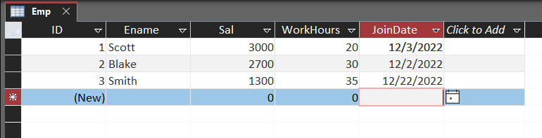

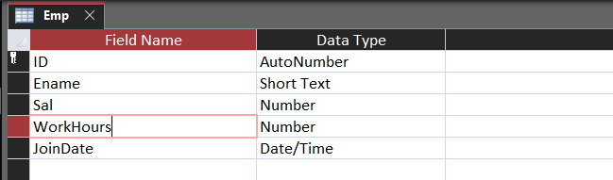

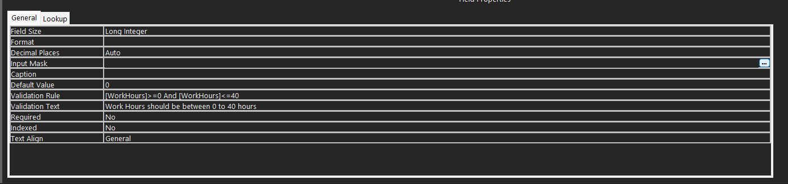

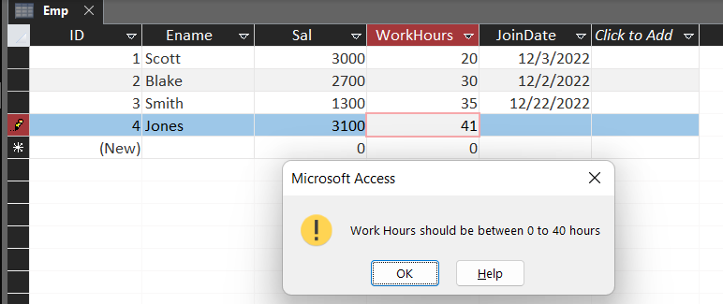

**2.Set a default date value in a text box when the user adds a new record.**

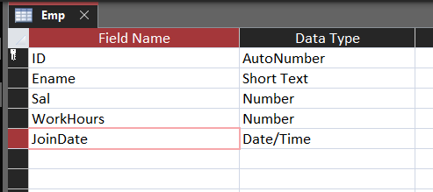

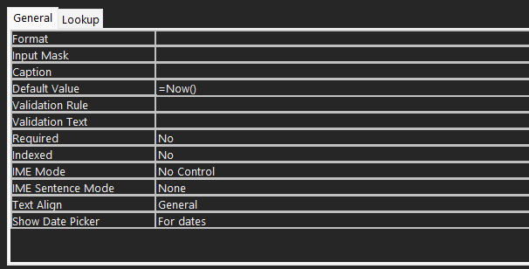

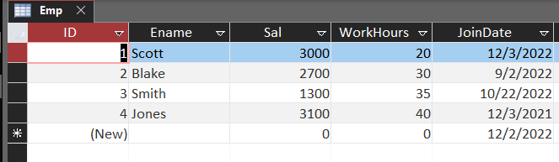

* Exercise

1. **Create a validation rule for a field that allows only values over 65 to be entered, if a number less than 65 is entered, a message is displayed.**

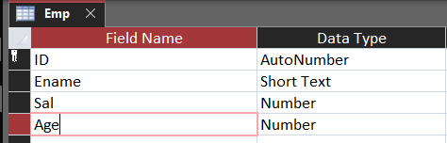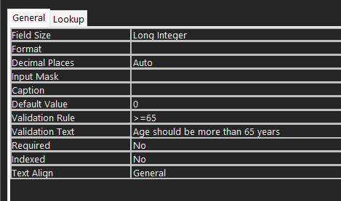

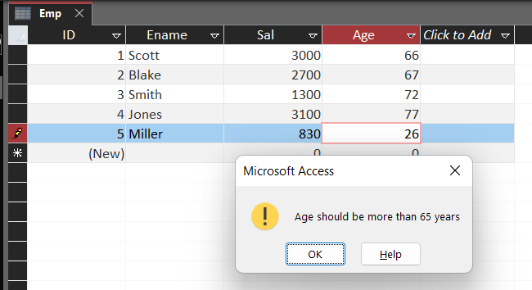

1. **Set course name as a default value in a text box when the user adds a new record.**

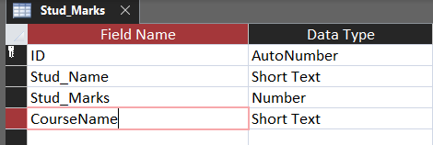

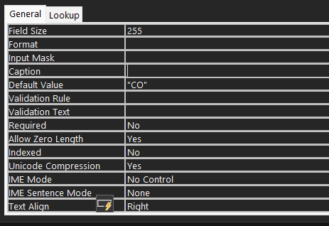

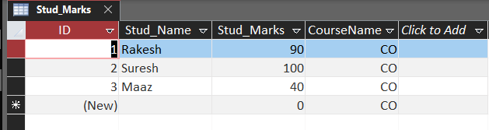

1. **Create a validation rule for a Parent Mobile No field that allows only any value that consists of 10 number values.**

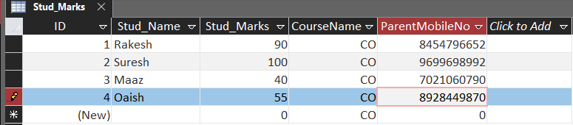

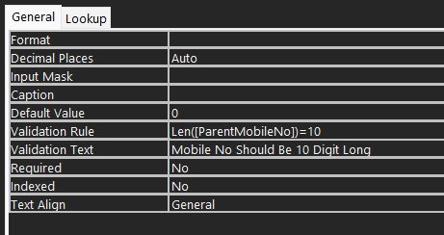

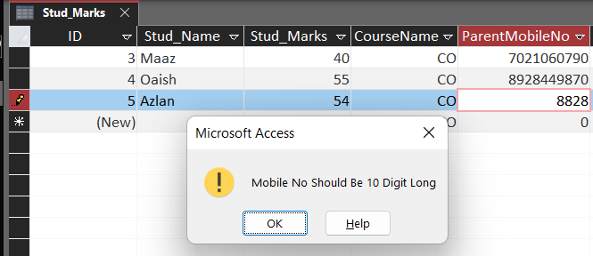

1. **Set a database-level password on a database**

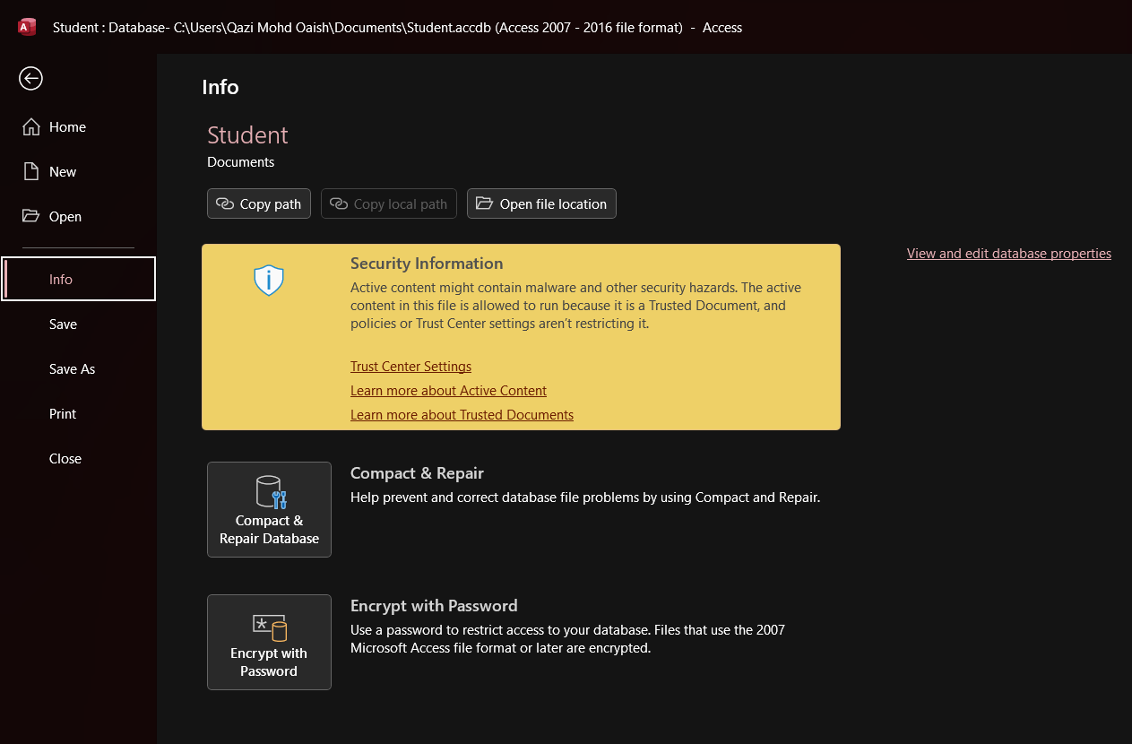

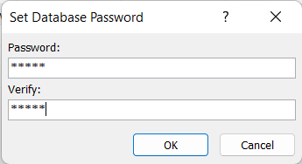 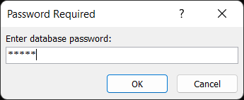

1. **Remove a database-level password from a database**



